HW2

這次作業主要分成三個部分，四張圖，第一二張圖利用DP解出對應點，透過對應點找出深度值，而以下是我做出來的成果

|  |  |
| --- | --- |
| D:\Program\CV_HW2\CV_HW2\images\pic001\pic001L.bmp |  |
| D:\Program\CV_HW2\CV_HW2\images\pic001\新資料夾\depth.jpg |

|  |  |
| --- | --- |
| D:\Program\CV_HW2\CV_HW2\images\pic002\pic002L.bmp |  |
| D:\Program\CV_HW2\CV_HW2\images\pic002\新資料夾\depth.jpg |

而第二個部分主要將找出圖片的R和T我們透過找尋左圖和右圖對應點的方式可以找到fundamental matrix透過fundamental matrix我們可以解出epipolar line以及旋轉平移矩陣

透過fundamental matrix找出的epipolar line為

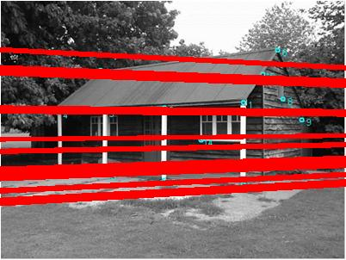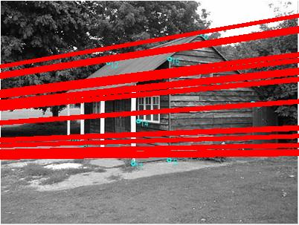

我們發現有些點他其實並沒有在epipolar line上，這表示我們做的fundamental matrix有一些誤差而我們透過normalize過再進行epipolar line發現效果真的比較好

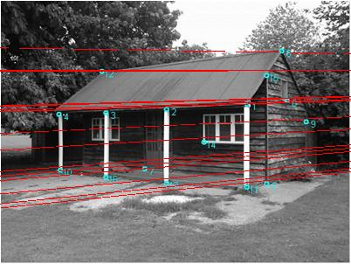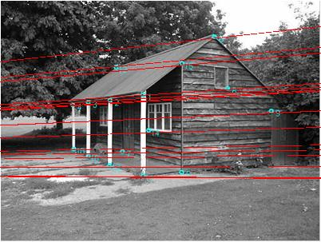

下表是一些相關數據

|  |  |  |  |  |  |  |  |  |  |  |  |  |  |  |  |  |  |  |  |
| --- | --- | --- | --- | --- | --- | --- | --- | --- | --- | --- | --- | --- | --- | --- | --- | --- | --- | --- | --- |
| 左邊normalize matrix nl   |  |  |  | | --- | --- | --- | | 0.00248756 | 0 | -0.492371 | | 0 | 0.00330033 | -0.491969 | | 0 | 0 | 1 | | 右邊normalize matrix nr   |  |  |  | | --- | --- | --- | | 0.00248756 | 0 | -0.452073 | | 0 | 0.00330033 | -0.491969 | | 0 | 0 | 1 | |
| Normalize過後的 F = nr\*f\*nl   |  |  |  | | --- | --- | --- | | 1.49371e-007 | 1.58268e-006 | -0.000152811 | | 1.51035e-006 | -1.15467e-006 | 0.00211653 | | -0.000349931 | -0.00233533 | 0.0651036 | | R   |  |  |  | | --- | --- | --- | | 0.156075 | 0.16959 | -0.169788 | | -0.987736 | -0.985515 | 0.984947 | | 0.00420625 | -0.000602367 | 0.0324193 | |
| T =[0.985469 -0.169852 -0.00079589] |  |

第三部分是用Rectification來將epipolar line從斜線變成直線，我們使用助教在投影片上面給的座標轉換法找到轉換矩陣，並且在兩張圖對齊上面我們透過 [ 0 0 0 ]

((T \* H)-1)T F H-1 = B = [ 0 0 -1 ]

[ 0 1 0 ]

(T-1)T (H-1)T F H-1 = B

(T-1)T A = B

我們可以得到下圖的兩個rectification後的結果

